Lesson plan 1: Basic styling using CSS

About the lesson
This lesson introduces students to HTML and CSS and explores the use of an external style sheet to control the styling of HTML pages. Students will learn how to use a range of basic CSS properties to control the font, text size and colour and background colour and how to add borders to an HTML element. They will also learn how to define and use classes to control the styling of specific HTML elements. They will apply this learning to practical activities using the HTML and CSS files provided.
Learning objectives
By the end of this lesson, students will be able to:
- edit an external style sheet to control the styling of an HTML document
- write and uses classes to control the styling of individual HTML elements.
National Curriculum
The following subject content from the KS3 National Curriculum is included in this lesson:
- Use two or more programming languages, at least one of which is textual, to solve a variety of computational problems
- Undertake creative projects that involve selecting, using and combining multiple applications, preferably across a range of devices, to achieve challenging goals and meeting the needs of known users
- Create, reuse, revise and repurpose digital artefacts for a given audience, with attention to trustworthiness, design and usability
Links
Websites are integral to modern life and link to every area of the curriculum and beyond.
Key terminology
HTML, elements, tags, CSS, CSS properties, external style sheet, selector, declaration, property name, value, CSS class
Teaching and learning activities
Share the objectives for the lesson with students (Slide 2 of Lesson 1 presentation).
Starter
Show students an image of some HTML and CSS and ask: Does anyone know what this code is used for? (Slide 3 and page 150).
It is the code for a browser to display a web page. Explain that a web page is effectively a document that can be viewed using a web browser. As well as text and images, it can contain sound, videos and links to other web pages and websites. The first image shows an HTML file that contains details of the structure and content of the web page and the second image shows a CSS file that defines the styling to be used when the web page is displayed.
Show students an image of the web page displayed by the code of the previous slide and explain the use of Lipsum to create dummy text to fill a page (Slide 4 and page 151).
Explain that some of the HTML code they will be using will be pre-populated with this to enable them to get a better idea of what their web page will look like without needing to type in lots of text.
Part 1
Explain the role of HTML (Slide 5 and page 151).
Explain the role of CSS and how a single CSS file can be used to control the styling for a whole website (Slides 6–7 and page 151).
Ask: Why is it best to use an external style sheet to control the styling of a website?
If you want to change something on every page of the website, for example, the font that is used or the background colour, you only need to edit the CSS file and every web page will be displayed using the new settings. If each web page has its own CSS, you would have to edit each page individually.
Explain the syntax for CSS style rules and introduce students to the property names for changing the text colour, background colour, font and font size (Slides 8–11 and page 151).
Emphasise the need for all HTML files and the CSS file for a website to be located in the same folder on your computer (Slide 12 and page 152).
- Advise students which text editor they will be using. Ideally, this should be a source code editor like Notepad++ on Windows or Brackets on MacOS, as these will help to format and colour the code so that it is easier to read and edit. However, Notepad or TextEdit may also be used.
- If using TextEdit, make sure that the file displays as HTML code rather than formatted text by clicking on 'TextEdit', 'Preferences', choosing 'Open and Save' and selecting 'Display HTML files as HTML code instead of formatted text'.
- When editing an existing .html or .css file, advise students to load the text editor and then open the file they require from within the text editor by selecting 'File', 'Open'.
Summarise the learning so far, to prepare students for the activity that follows (Video 1.1).
Ask students to complete Activity 1.1: Styling using CSS (Slide 13, pages 150–152/Worksheet 1.1, plus lesson1_index.html and lesson1_style.css).
Check that students have saved 'lesson1_style.css' after they have edited it and have refreshed the web page in the browser so that the new styling is applied.

Answers
1.
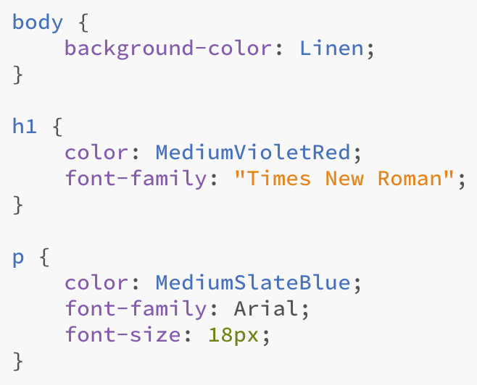
2.
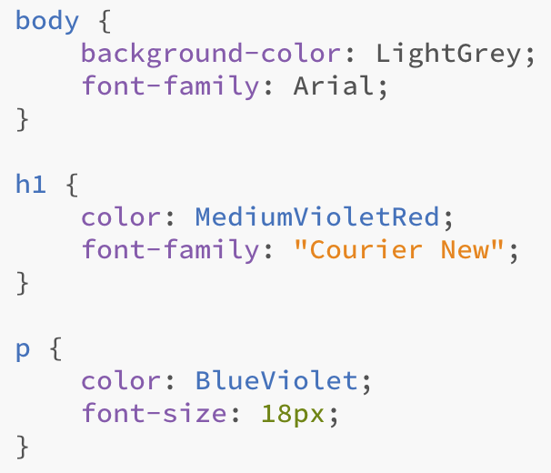
Part 2
Explain CSS classes (Slides 14–15 and page 152, plus Video 1.2).
Note that class names are defined by the user and should relate to the styling in some way so that they can be identified and applied easily.
Ask students to complete Activity 1.2: Styling using CSS classes (Slide 16, pages 151–152/Worksheet 1.2, plus lesson1_index.html and lesson1_style.css).
Check that students have saved 'lesson1_style.css' after they have edited it and have refreshed the web page in the browser so that the new styling is applied.

Answers
1. a.
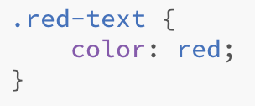
b.
2. a.
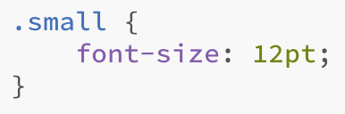
b.
3.
4. The code will vary from student to student because students should select their own values. Look for changes to the font, text colour and background colour, and the use of at least two different classes.
Ask students to complete Activity 1.3: Challenge exercise (Slide 17, page 152/Worksheet 1.3, plus lesson1_index.html and lesson1_style.css).
Answers
lesson1_style.css
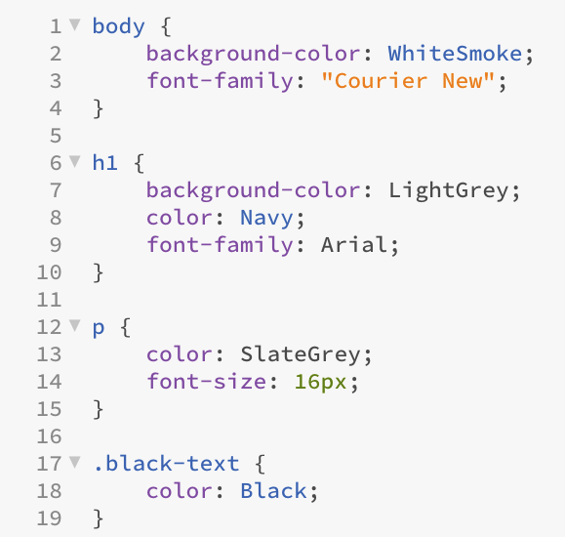
lesson1_index.html
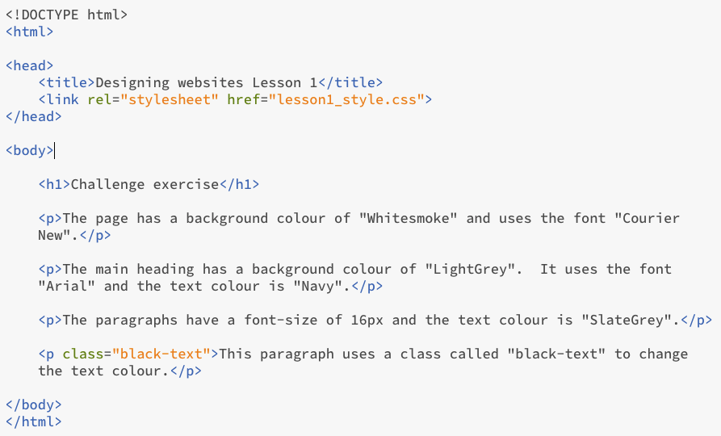
Plenary
Check students' knowledge and understanding with a short question and answer session linked to the learning objectives for the lesson.
- What does CSS stand for?
(Answer: cascading style sheet)
- What is CSS used for?
(Example answer: To format the styling of a web page.)
- What does HTML stand for?
(Answer: Hyper Text Markup Language)
- What is HTML used for?
(Example answer: To describe the structure and content of a web page.)
- What is a CSS class?
(Example answer: A style that is applied to specific elements on a web page.)
Homework
Ask students to complete any activities they did not finish during the lesson.
Ask students to complete Quiz 1 (Slide 18).
Stretch activities
Students who complete the activities in this lesson quickly could be encouraged to create additional CSS classes to control other aspects of the formatting via the HTML file. They could also explore the use of RGB values or HEX values to specify the colours to be used. Information regarding this can be found at https://www.w3schools.com/html/html_colors_rgb.asp
Encourage students to split their screen so that they can see the HTML or CSS code on the left-hand side and the page display in a browser on the right-hand side. They should be able to apply a change and save the file, and then simply refresh the browser display to view the results.
Support activities
Some students may benefit from working with a partner initially, and should be encouraged to build their confidence when editing the code by making just one change at a time and checking that this displays correctly before making further adjustments.
A number of short and informative videos about CSS can be found online, such as https://www.youtube.com/watch?v=XPv4EeB0PJ8 which slightly extends the learning from this lesson.

